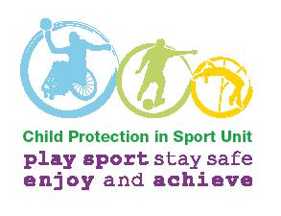
CPSU procedure flowcharts

Outline safeguarding reporting procedure concerns

- About the behaviour of the organisation’s staff member or volunteer

(e.g. allegation about a coach or officer’s behaviour towards a child)

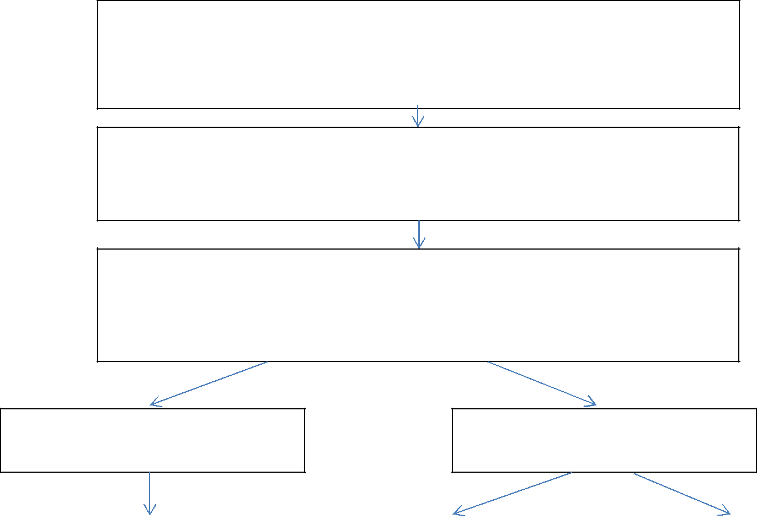
Concerns arise about the behaviour of a member of staff, coach or volunteer

towards a child/children.

(e.g. suspicions or allegations of poor practice or possible abuse)

Individual alerted to concerns reports to organisation / club / facility or event.
Safeguarding Lead Officer completes the safeguarding incident report form
and forwards a copy to the Safeguarding Lead.

Safeguarding Lead Officer (if appropriate in consultation with Case Management
Group and / or Children’s Social Care, Police or LADO) determines the route for
further action to be taken (e.g. does the matter appear to be poor practice or
possible abuse and records actions taken and agree).

Poor Practice/Breach of Code of

Conduct

Possible Child Abuse/Criminal

Offence

Concern dealt with as misconduct |  | In consultation with statutory |  | Safeguarding LO consults
issue using complaints / disciplinary |  | agencies and LADO: |  | with/refers to Children’s Social
procedures as appropriate (in |  | Safeguarding LO consults |  | Care/Police and LADO and
consultation with LADO). |  | with/refers to HR/Disciplinary |  | follows this up in writing within
 |  | lead/s re initiating disciplinary |  | 24 hours.
 |  | procedures, immediate
 |  | temporary suspension
 |  | (without prejudice), and
Disciplinary investigation undertaken
 |  | notification of other |  | Children’s Social Care and/or
and hearing held.
 |  | organisations. |  | Police hold Strategy Meeting
 |  |  |  | (may include sports
 |  |  |  | organisation rep) and agree
Outcome of disciplinary process (e.g.
 |  | Disciplinary process initiated –
 |  |  |  | investigation process
no case to answer, advice or warning
 |  | investigation may be delayed
given, training / support required,
 |  | pending outcome of statutory
other sanctions, or exclusion).
 |  | agencies’ processes. Support
Consideration of referral to DBS, if
 |  | from LADO. |  | Outcome of Children’s Social
appropriate.
 |  |  |  | Care or Police investigation
 |  |  |  | (e.g. NFA, criminal
 |  | Full disciplinary investigation
Disciplinary appeals process |  |  |  | prosecution, assessment of
 |  | undertaken and hearing held
 |  |  |  | risk etc.)
 |  | outcomes and possible
 |  | appeal.

CPSU procedure flowcharts

Outline safeguarding reporting procedure concerns

- About the behaviour of another organisation’s staff member or volunteer

(e.g. allegations reported about an individual working for a partner organisation)

Concerns arise about the behaviour of a member of staff, coach or volunteer from

another organisation towards a child/children

(e.g. suspicions or allegations of poor practice or possible abuse)

Individual alerted to concerns reports to organisation/club/facility or event. Safeguarding Lead Officer completes the safeguarding incident report form and forwards a copy to the Safeguarding Lead.

Safeguarding Lead Officer (if appropriate in consultation with Case Management Group and / or Children’s Social Care, Police or LADO) determines the route for
further action to be taken (e.g. does the matter appear to be significant poor practice
or possible abuse, and records actions taken and agreed).

Poor practice / breach of code of

conduct

Inform subject of concerns of intention to pass information to employing / deploying organisation safeguarding lead in line with safeguarding policy and / or any inter-organisation information sharing arrangements.

Contact safeguarding lead in

employing / deploying organisation

and pass on concerns. Record

actions and plans agreed. Follow up in writing within 24 hours, cc’ing the individual.

Possible child abuse / criminal

offence

If matter appears urgent and indicates a high level of risk to child/ren, either contact Children’s Social Care or Police direct to refer,

or

Contact the safeguarding lead in the

individual’s employing/deploying

organisation to pass on the

information. Secure and record their

commitment to refer to statutory agencies, and seek confirmation when this has been undertaken. If not agreed - contact statutory agencies directly.

Safeguarding Lead Officer records

actions and plans agreed and follows

up referrals in writing within 24 hours.

CPSU procedure flowcharts

Outline safeguarding reporting procedure concerns

- About children and young people arising outside of sport (e.g. at home, school or in the community)
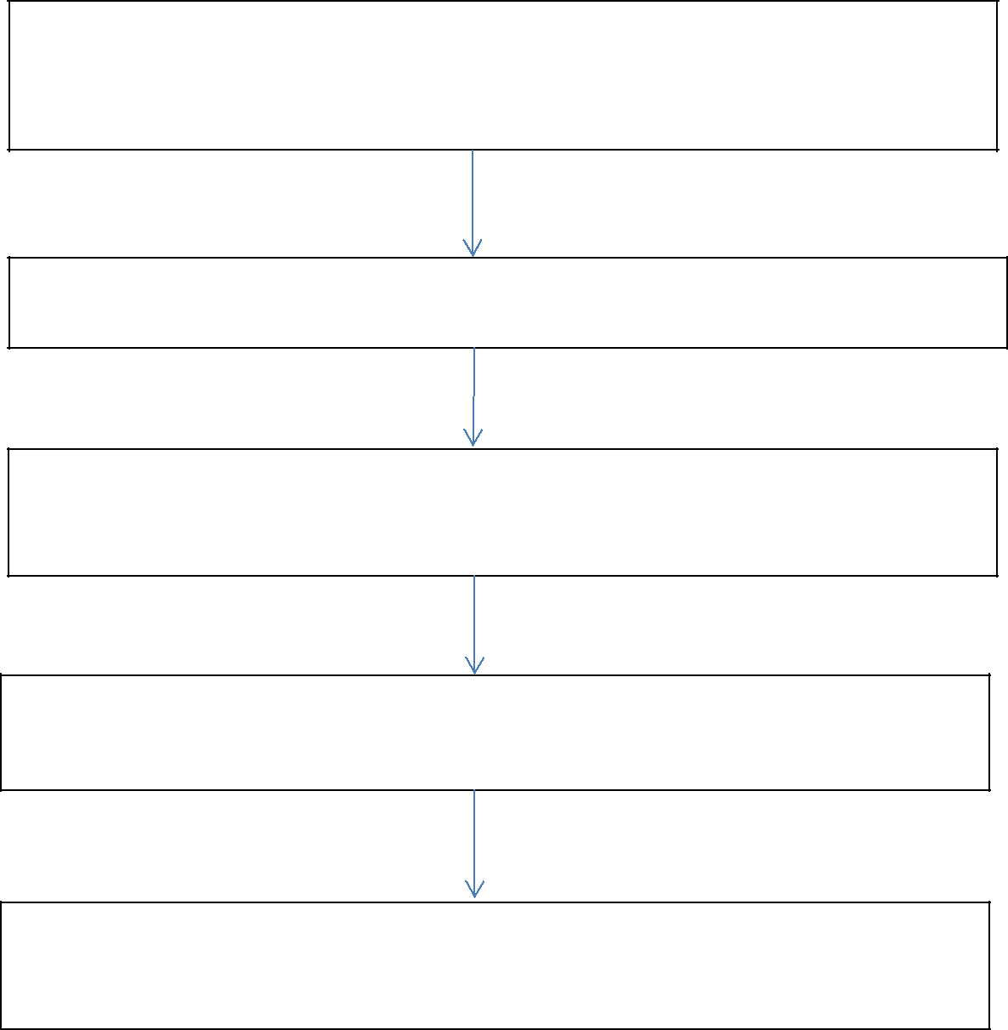

Member of staff, coach or volunteer made aware of concerns

about child’s welfare or safety.

(e.g. suspicions of bullying at school, allegations of abuse within the family etc.)

If child requires immediate medical attention arrange this and ensure that medic is

informed that there may be a child protection concern or allegation.

Member of staff, coach or volunteer reports to/consults with organisation/club/facility
or event Safeguarding Lead Officer, and completes the safeguarding incident report
form and forwards a copy to the Safeguarding Lead.

Safeguarding Lead Officer makes decision on immediate referral to or consultation
with Children’s Social Care or Police; records actions taken / agreed (including who
will inform parents).

Safeguarding Lead Officer sends written safeguarding report
to Children’s Social Care / Police within 24 hours, and considers need for support or
advice for original referrer or others involved.

